**Best Blood Donor Award for 2023-2024**

Donating blood is an essential and selfless gesture that preserves numerous lives each year. The significance of having an adequate blood supply for medical procedures cannot be emphasized enough. PRIST Deemed to be University’s along with Thanjavur Medical College has continually fostered the culture of voluntary blood donation through awareness initiatives and blood donation events. In this regard, our University was honored with the **Best Blood Donor Award for 2023-2024** by the Hon. District Collector for showing outstanding dedication to this noble cause.

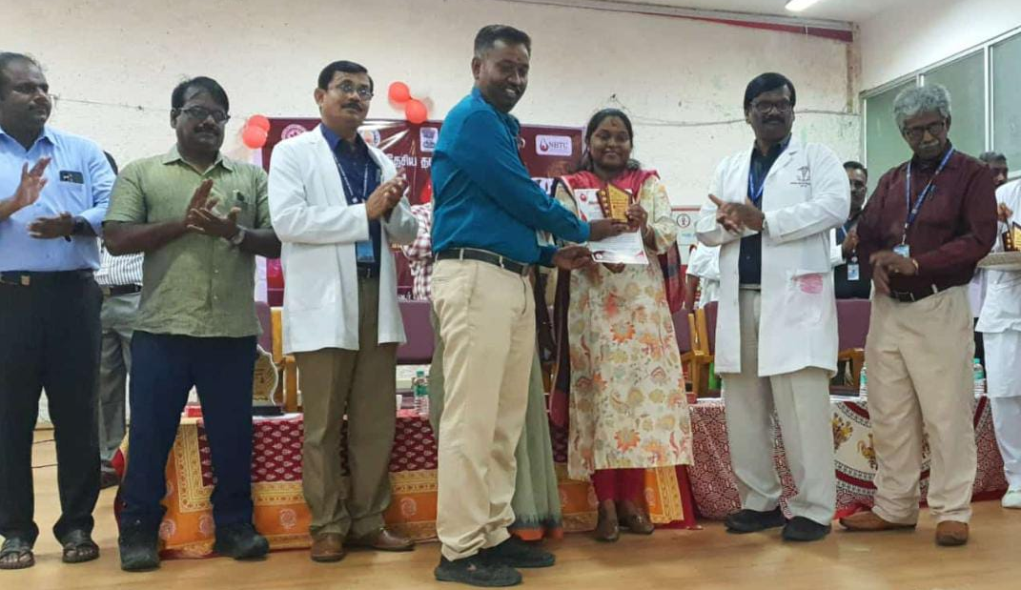

**Our NSS Coordinator Received Best Donar Award received from Honorable District Collector Thanjavur along with Dean Thanjavur Medical College.**

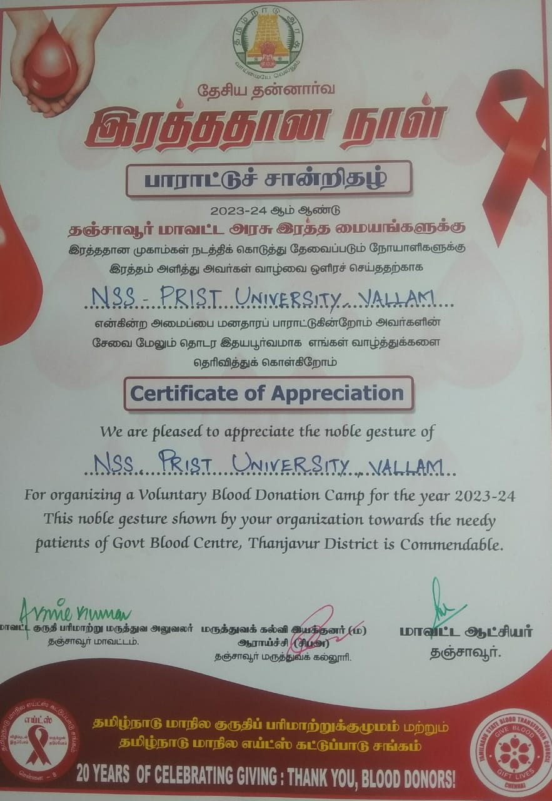

**Certificate of Appreciation**