**Consumer Awareness Rally**

The PRIST Deemed to be University along with Collector Office Thanjavur organized a mass rally to raise awareness about Consumer awareness on 06.03.2025.

About 500 students and NSS volunteers are participated in the rally. They held placards and banners with awareness messages and advocacy of Consumer awareness. The rally, which started at Thanjavur Railway junction, ended near Old Bus stand.

Honorable District Collector flagged off the rally and her message Consumer awareness is important because it helps consumers make informed decisions and protect their rights.

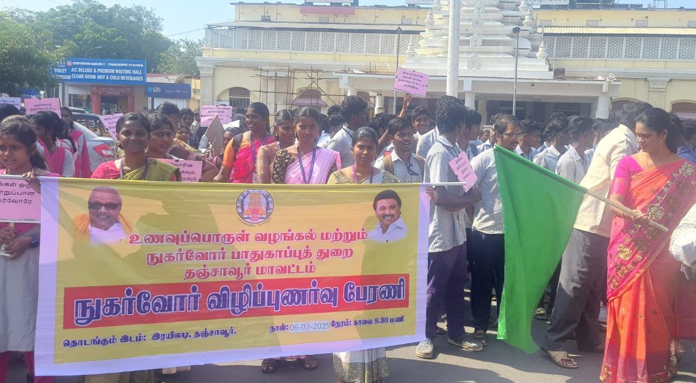

**Honorable District Collector flagged off the rally**

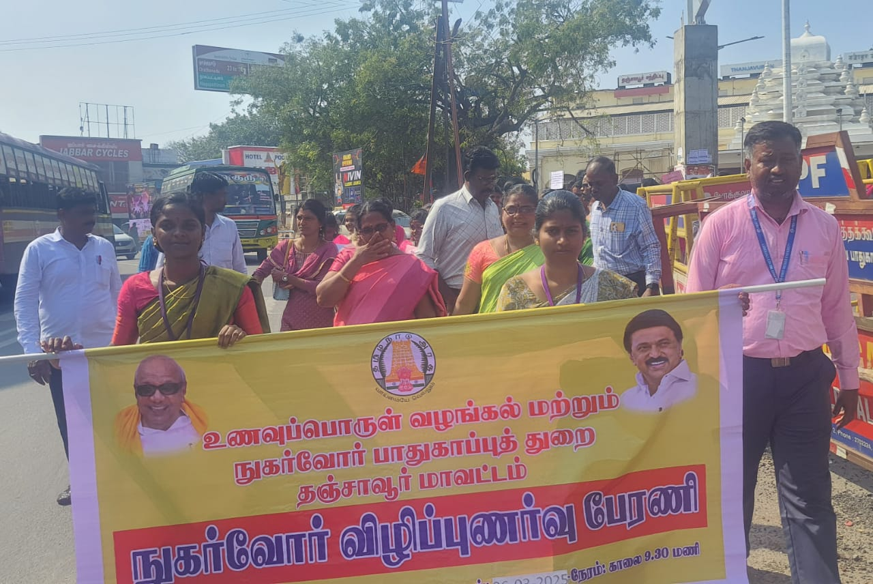

**Our NSS Coordinator Dr.R.Manikandan Lead the Rally**

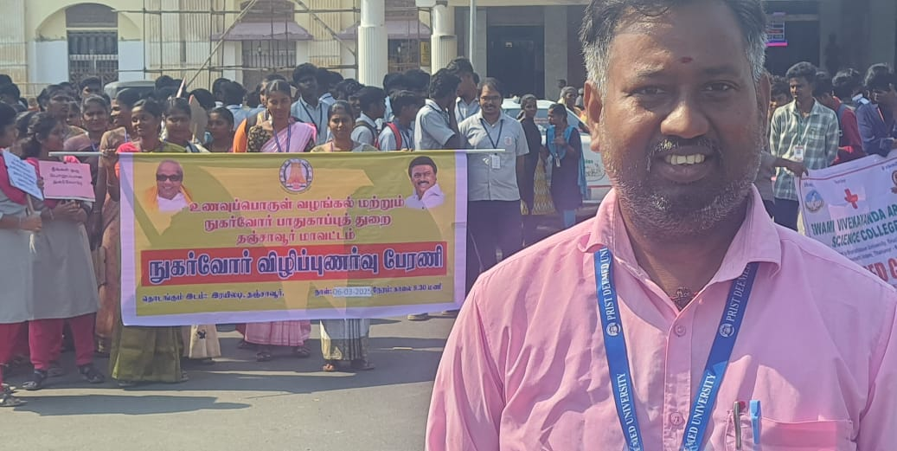

**Our volunteers actively participated the rally**