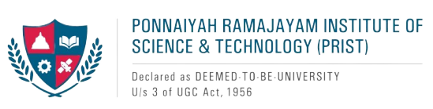

The Career Counselling Development Cell aims to equip students with the tools they need to realize their professional goals by delivering tailored guidance, resources, and support. Dedicated to fostering a culture of lifelong learning, the Centre helps students develop essential skills and knowledge to navigate and excel in a dynamic, ever-evolving employment landscape.

The core mission of the CCDC is to offer students a comprehensive range of career-focused services designed to prepare the graduates of Ponnaiyah Ramajayam Institute of Science & Technology (PRIST) Deemed to be University for challenges they would face within the professional world. The central goals of the CCDC include:

Objectives of the Career Counselling Development Cell:

* Making available resources and guidance for students to explore career options
* Skill enhancement of students to succeed in the professional world.
* To help students make informed decisions from among the offers made by employers.
* To organize seminars, workshops, and guest lectures featuring industry professionals, providing students with real-world insights.
* To facilitate internships and placements, bridging the gap between academia and the professional world.
* To assist students in identifying their strengths and weaknesses, fostering self-awareness and personal growth.