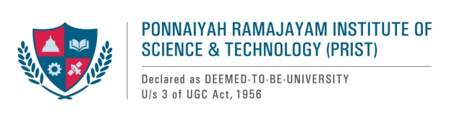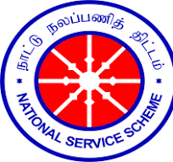

**REPORT ON ANTI-DRUG AWARENESS CAMPAIGN**

1. **Name of the Activity** : Anti-Drug Awareness Week
2. **Date of Activity** : 26-11-2024
3. **Organized by/Name of the committee** : PRIST -NSS UNIT
4. **Activity objectives**

1. Empower students to make informed decisions related to use of alcohol and other drugs.

2. Emphasize an awareness of choice, personal responsibility, and understanding of consequences in deciding to use alcohol and other drugs.

3. Encourage the campus community to prevent alcohol and drug-related incidents.

**5. Report:**

Under the auspices of NSS, our university held an anti-drug awareness week. Our NSS students who volunteered for the event took part in a number of activities, including painting, writing essays, and a slogan competition with the topic "Say No to Drugs." Our NSS program officers put that poster on the university notice board to raise awareness among the students. Honorable Vice Chancellor Dr. T.V. Christy, who inspired the students and awarded awards to the winners, stated that this program has a bigger duty to raise awareness of this issue. "Life is a priceless gift from God. You should avoid drug abuse and keep it properly. You should educate your friends about this as well.

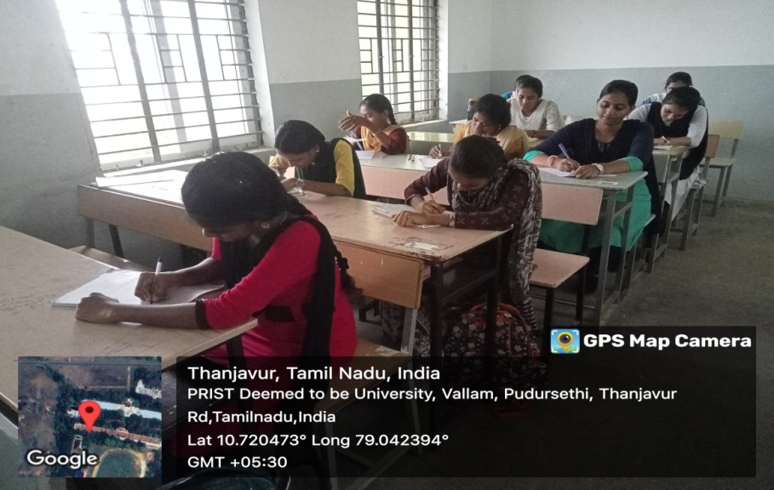**Glimpses of the program**

**Students writing essays, with the topic "Say No to Drugs."**

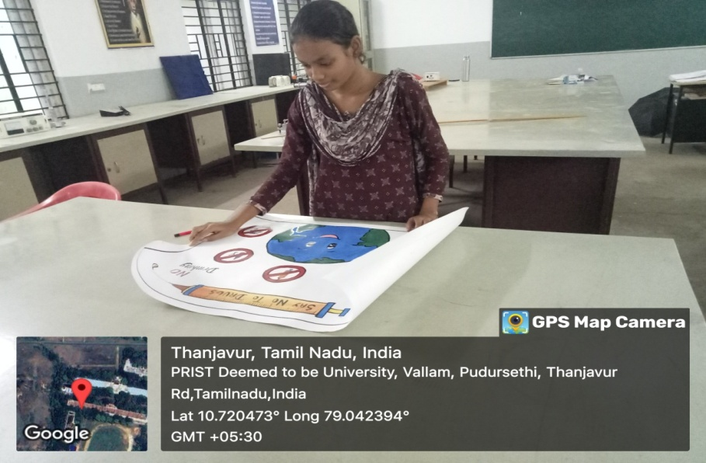

**Students Paintings with the topic "Say No to Drugs."**

