**Systematic Voters’ Education and Electoral Participation (SVEEP) Rally**

The PRIST Deemed to be University along with Elections Department Thanjavur organized a mass rally to raise awareness about ethical voting and quell misinformation, as part of Systematic Voters’ Education and Electoral Participation (SVEEP) initiative.

About 500 students and NSS volunteers are participated in the rally. They held placards and banners with awareness messages and advocacy of voter participation. The rally, which started at Thanjavur Railway junction, ended near Old Bus stand.

Honorable District Collector flagged off the rally that has set a target to achieve cent per cent voting among youth. As per the final electoral rolls released in January, Thanjavur has a total of 27,000 first-time voters.

The DEO, while explaining the mechanisms to report Model Code of Conduct (MCC) violations, reiterated that the identity of the persons making complaints would be kept confidential. He also urged voters to avoid using vehicles and, instead, walks to the polling stations.

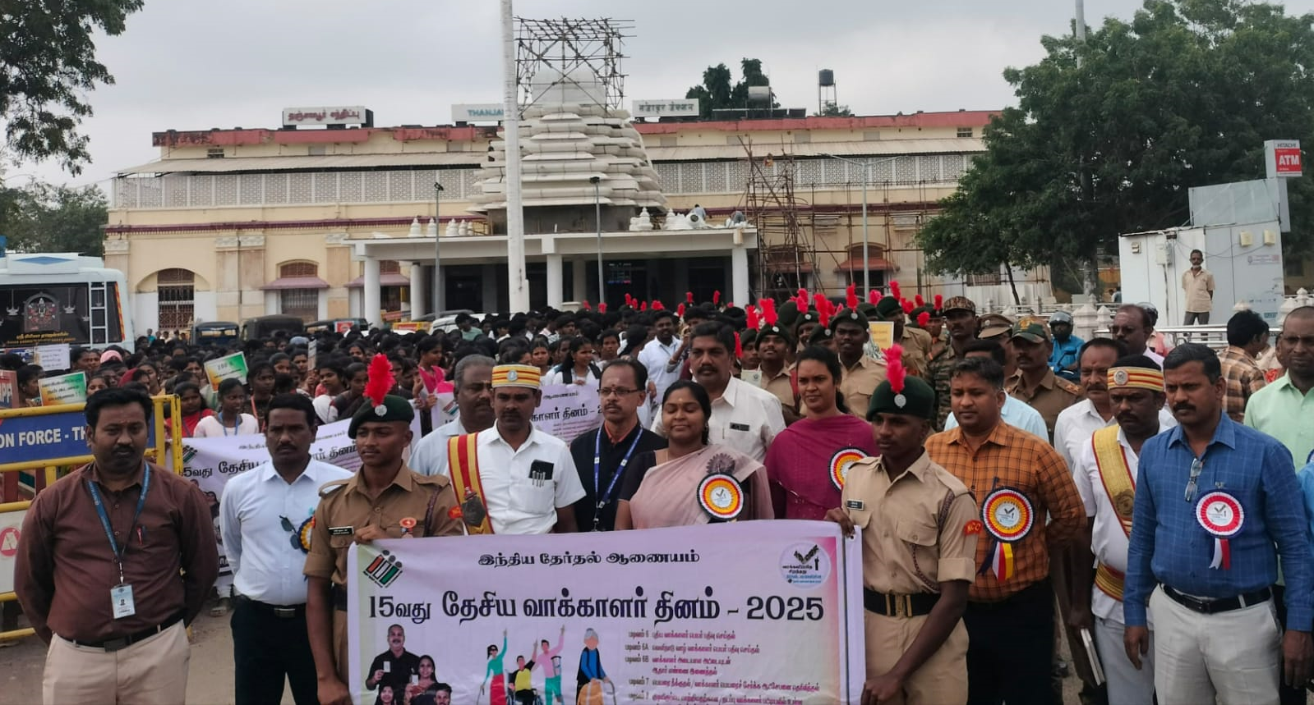

**Honorable District Collector flagged off the rally**

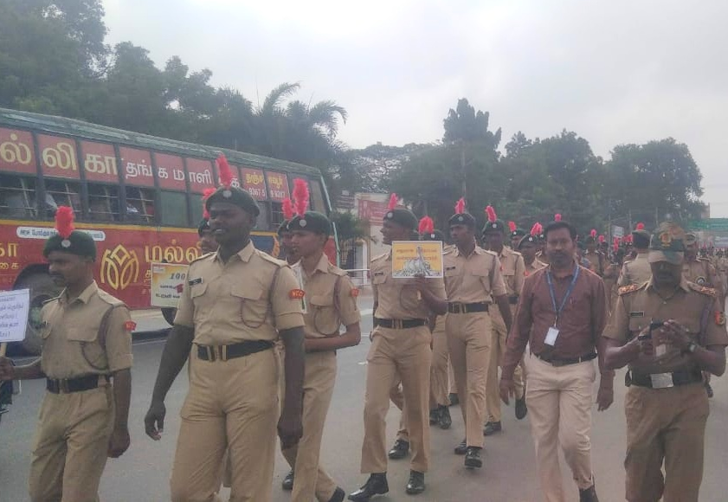

**Our NSS Coordinator Dr.R.Manikandan Lead the Rally**

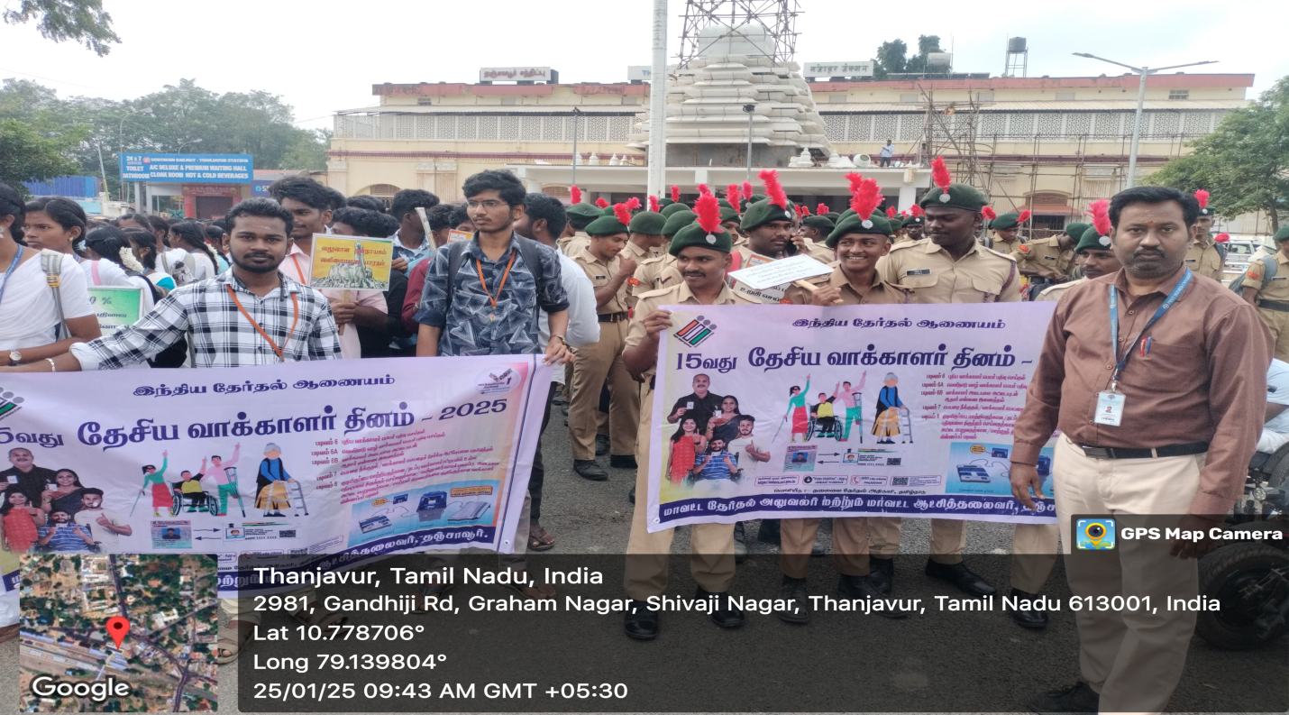

**Our volunteers actively participated the rally**

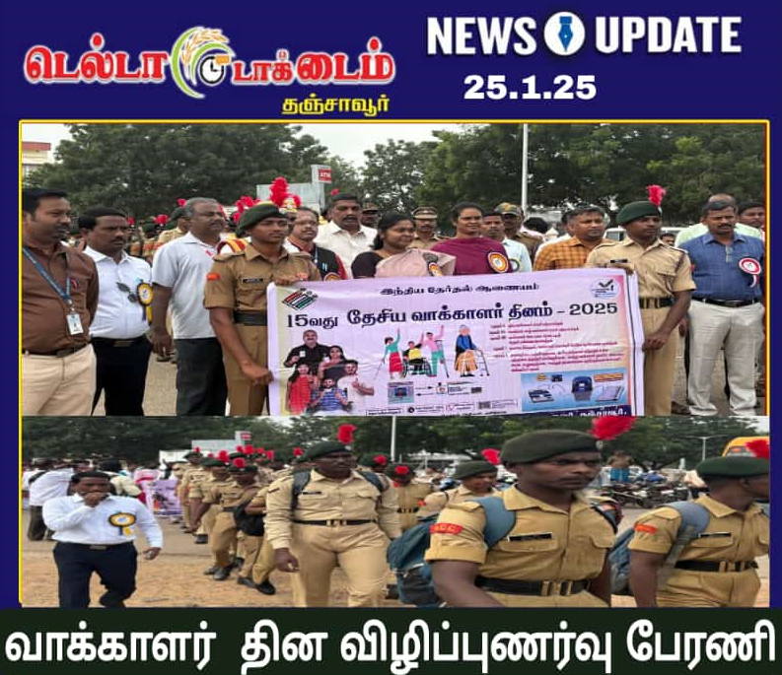

**Event News published in Delta talk times**